Chapter 3. Selection Statements
Java provides selection statements that allow the program to choose between alternative actions during execution. The choice is based on criteria specified in the selection statement. These selection statements are
- simple if Statement
- if-else Statement
- switch Statement

Simple if Statement
The simple if statement has the following syntax:
if(<conditional expression>)
<statement>
It is used to decide whether an action is to be performed or not, based on a condition. The condition is specified by <conditional expression> and the action to be performed is specified by <statement>.
The semantics of the simple if statement are straightforward. The <conditional expression> is evaluated first. If its value is true, then <statement> (called the if block) is executed and execution continues with the rest of the program. If the value is false, then the if block is skipped and execution continues with the rest of the program.
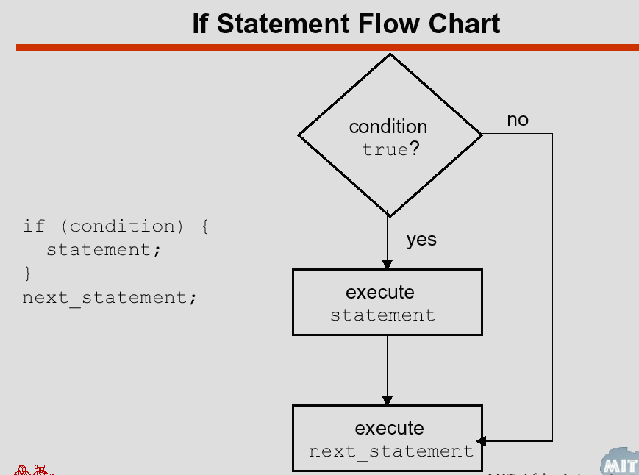
In the following examples of the if-else statement, it is assumed that all variables and methods have been defined appropriately:
if (emergency)
operate();
else
joinQueue();

if (temperature > critical)
soundAlarm();

else
businessAsUsual();

if (catIsAway()) {
getFishingRod();
goFishing();
} else
playWithCat();

if-else Statement
The if-else statement has the following syntax:
if(<conditional expression>)
<statement₁>
else
<statement₂>
It is used to decide between two actions, based on a condition.
The <conditional expression> is evaluated first. If its value is true, then <statement₁> (the if block) is executed and execution continues with the rest of the program. If the value is false, then <statement₂> (the else block) is executed and execution continues with the rest of the program. In other words, one of two mutually exclusive actions is performed. The else clause is optional; if omitted, the construct reduces to the simple if statement.
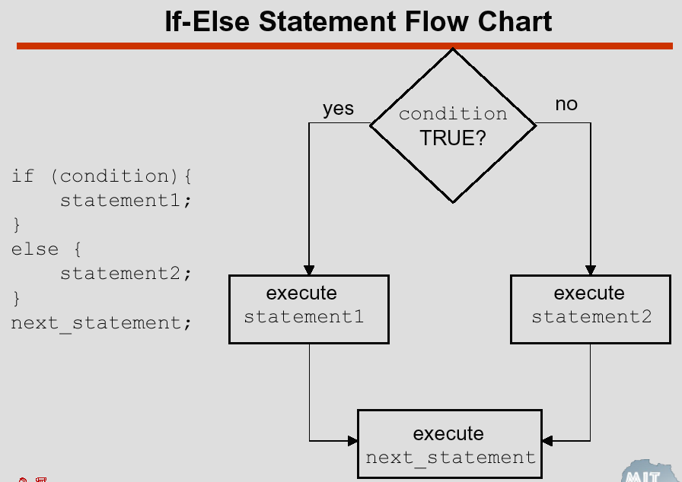

Else if Ladder
By using Else If, it is possible to combine several conditions. Only the statements following the first condition that is found to be true will be executed. All other statements will be skipped. The statements of the final Else will be executed if none of the conditions are true.
if condition then
-- statements;
elsif condition then
-- more statements;
elsif condition then
-- more statements;
...
else
-- other statements;

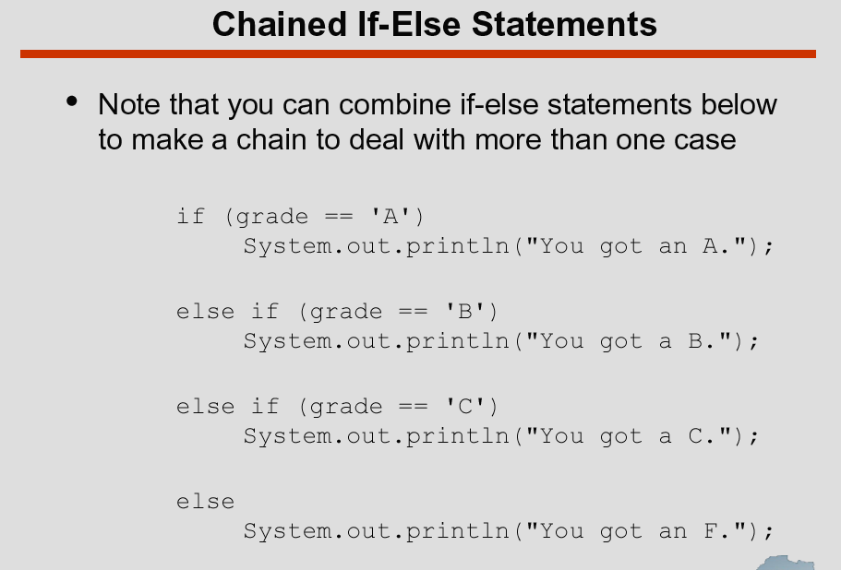

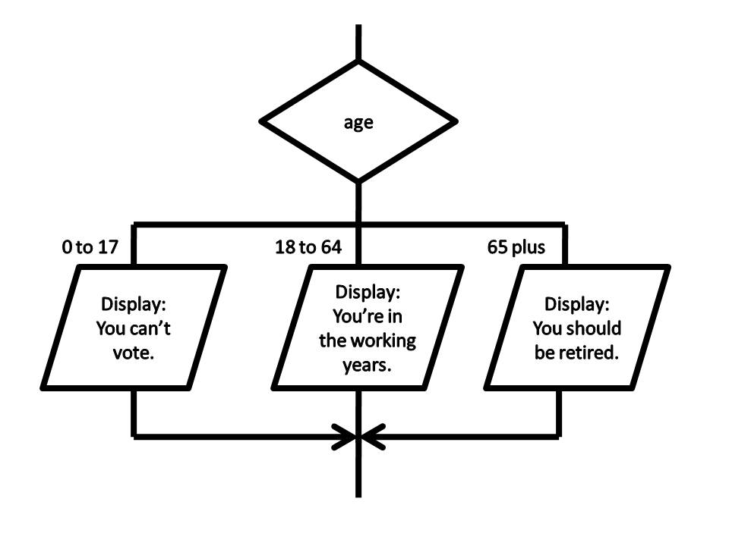

public class Demo {

public static void main(String[] args) {

if (false)

if (true)

System.out.println("a");

else

System.out.println("b");

}}

What will get print when the above program is executed: Ans: Nothing

//Note: The if and else can have empty body. For e.g.

if (false) ; else ;

